

Our Trust Mission

Supporting all, delivering excellence and enriching the lives of young people

Our academies are places of educational excellence, where all are challenged to succeed in a caring and supportive environment.



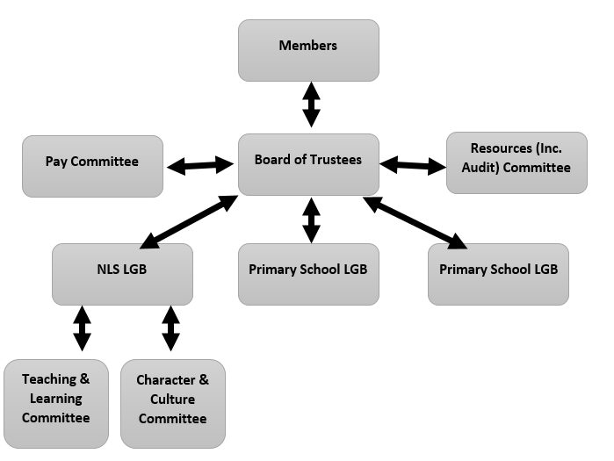

Elm Tree Multi Academy Trust

Mike Lowdell

CEO and Head Teacher of North Leamington School

[mlowdell@northleamington.co.uk](mailto:mlowdell@northleamington.co.uk)

Richard Freeth

Chair of Trustees

[rfreeth@northleamington.co.uk](mailto:rfreeth@northleamington.co.uk)